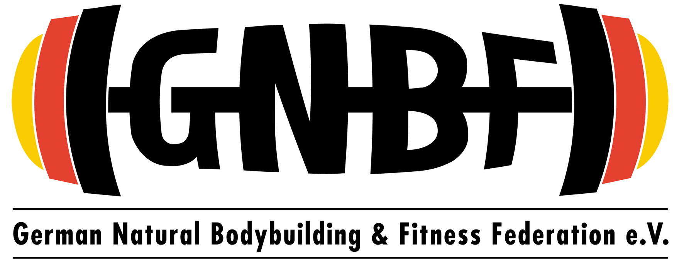

**INTERNATIONAL GERMAN CHAMPIONSHIPS 2019   
  
ATHLETE-INFORMATION** **Hamburg, May, 07th, 2019**

**Dear Athletes,**the 5**th GNBF international German Championships** are just around the corner! **Actually 200 competitors from 28 nations**  have signed in for the contest for doing stage-battle on May, 18th, 2019 to win their single categories as well as being crowned as overall champions in their divisions and getting their PNBA Pro-Card! Top 3 athletes of each class qualify for competing at the INBA Natural Mr. Olympia on November 14th – 17th 2019 in Las Vegas/USA.

**Preliminary classification:  
Dating 07th May, 2019 – five days before deadline of entry application via** [www.gnbf.d](http://www.gnbf.de)e **,** the preliminary classification of competitors (inklusive cross-overs) looks as follows. The final classification of competitors gets defined at the days of signing in via measuring Body Height and controlling identity card of each competitor.  
 **Teens** (15 to 17 years):  **4  
Juniors I** (18 to 22 years / up to 175 cm Body Height): **8  
Juniors II (**18 to 22 years / over 175,1 cm Body Height):  **13  
Men`s Classic Physique: 4  
Men I** (up to 170 cm Body Height): **11  
Men II** (170,1 cm to 175 cm Body Height): **12  
Men III** (175,1 cm to 180 cm Body Height): **18  
Men IV (**180,1 cm to 185,0 cm Body Height): **8  
Men V (**over 185,1 cm Body Height): **9  
Masters I** (40 to 49 years): **8  
Masters II** (50 to 59 years): **7  
Masters III** (60+ years): **3  
Mr. Physique I** (up to 177 cm Body Height): **21  
Mr. Physique II** (177,1 cm to 182,0 cm Body Height): **17  
Mr. Physique III (**over 182, 1 cm Body Height): **22  
Ms. Physique: 7  
Fitness-Bikini I** (up to 170 cm Body Height): **22  
Fitness-Bikini II** (over 170,1 cm Body Height): **10  
Fitness-Bikini 40+ years: 3  
Women`s Sport Modell: 9  
Fitness-Figure: 5  
Fitness-Figure 35+ years: 4**

**Signing in for the competition**  
Signing in for the competition is scheduled for Friday, 17th, May 2019 from 8:00 am to 7:00 pmin the Weser-Ems-Halle left side of building (you will see red doors there and a GNBF-Logo there. Parking space is directly infront of Sign-In-Faciliaty. Costs for parking is 3,- Euro per day.

To avoid longer waiting periods on Friday evening, it is highly recommended to sign in for the contest on Friday morning respectively on Friday midday.

Important notice: Athletes who are not present at sight on Friday no later than 7:00 pm are not eligible to compete at the show. Door closes at 7:00 pm on Friday to sign in. In case of unforseen circumstance (i.e. delay of train or breakdown of car) it is absolutely neccescary to call Mr. Arthur Bill via Mobil Phone Nr.: 0152-53874724

**For keeping the process of signing in running smoothly, it is highly recommended to sign in as early as possible on Friday.**

**At signing in following items has to be shown:**\* **Identity card**  
* **GNBF – Membership card** **or** **Membership-Card of the Natural Bodybuilding Federation of your   
 country.** In case the Natural Bodybuilding Federation of your country doesn`t handle out membership card a   
 printed written confirmation of your membership from the President of your Federation has to be shown.  
  
* **INBA GLOBAL EUROPE Membership-Card.** In case you like to compete in the INBA GLOBAL ELITE TOUR and   
 don`t have your membership-card yet, you can purchase your INBA GLOBAL EUROPE membership-card   
 directly at sight on Friday at the day of signing in for € 50,00, to pay only in cash

* **Posing-Music.** If you reach the Finals (Top 6) in the Bodybuilding- Classes, Men`s Classic Physique-Classor the Ms. Physique-Class and like to perform your individual posing routine, please notice the minimum time span of Posing-Music is 45 seconds, maximum duration is 60 seconds. Music has to be saved on an USB-Stick via MP3 or WAV-Format. If you any questions about this issue please contact Mr. Thomas Keller via E-Mail: [thomas@gnbf.de](mailto:thomas@gnbf.de)   
  
* **Signed List of forbidden substances.** Print out attached list and sign or sign directly at day of signing in.

* **GNBF Anti-Doping Rules.** No englisch translation available. Print out attached rules and sign or sign directly   
 on sight during signing in for the contest on Friday, if you got any further questions about this   
 issue we clear it directly in Oldenburg.

**At signing in following fees have to be paid:**\* **Yearly GNBF-membership fee** **2019** (45,- Euro – if you are not a member of a foreign Natural Bodybuilding   
 Federation)   
* **GNBF one-time admission fee** (25,- Euro – only for new GNBF members in 2019)  
* **Entry-Fee** for competing at the GNBF international German Championships 2019 **95,- Euro / Crossover class   
 additional 55,- Euro**

**In case you haven`t paid any of the above mentioned fees required to be eligible to compete you can pay outstanding fees only in cash at the days of signing in.**

**Drug-Testing  
Urine-, Blood or Hair-Tests.**

**At the day of signing in:** Urine drug-testing will be done according to the random principle. In case you are choosed for Urine drug-testing, you will get contacted by Mr. Jablonski, the CEO of Institut Global Quality Sports ([www.gqs-antidoping.de](http://www.gqs-antidoping.de)) and his co-worker Ms. Kirsten Reith while you are signing in for the contest.   
The FFMI (Fat-Free-Body-Mass-Index) gets defined via usage of measuring Body Height and Body Weight with propably assistance of a caliper. Every competitor in the Bodybuilding-Classes has to undergo FFMI measurement. Competitors with an FFMI higher than 26 are not eligible to compete. Eventually needed further information about this issue please search online, i.e. www.gnbf.de.   
Mr. Jablonksi and Ms. Reith will do also pick out athletes by the random principle to get in conversation with choosen athletes and to look at their body for signs of possibly drug use (injections marks, acne, swollen breast tissue). It is his decision to do drug-testing in case of eye-catching signs of possible drug use.

**Contest Day:** Winner of Men Bodybuilding-Classes, winner of Mr. Physique-Classes, winner of Men Classic Physique-Class and winner of Ms. Physique-Class will get possibly drug-tested at the end of championships. Drug Testing will consist of Urine-Test and possibly additionall Blood- or Hair-Test. Winner of Women Fitness-Bikini-Classes and winner of Women Fitness-Figure-Classes has to undergo possibly Urine-Test only at the end of championships. In addition, more athletes can be choosed for Drug-Testing according to the random principle, independently of their placing. In case you are choosed for Drug-Testing you will get contacted by one of the Anti-Doping-Chaperones located in the backstage area, who will accompany you until Drug-Testing is completed.

All Drug-Samples (Urine, Blood, Hair) gets analyzed in a WADA accredited laboratory, either in the „Institute for Dopinganalysis and Sportsbiochemistry“ ([www.idas-kreischa.de](http://www.idas-kreischa.de)) or in the „Institute for Biochemistry“ at the Physical Education College Colonge ([www.dshs-koeln.de](http://www.dshs-koeln.de))

**Trainer-Pass:**

Backstage area entry as well as entry in the warm up room is only allowed for competing athletes and GNBF staff. In additon, at the day of signing in, a trainer-pass could purchased for 35,- Euro each pass. Holder of trainer-Pass is allowed to go backstage, in the warm up room and in the contest hall (no reserved right for seated place) all day long. The trainer-Pass has to be worn visible on person and is not allowed to pass on to somebody else for avoiding of getting too many people backstage. Only one trainer-Pass per athlete gets handled out at the days of signing in.

**Pumping up Equipment**:  
It is recommendend to bring your own pumping up equipment too, like resitance bands, Towel, expander etc…

**Ticket Sale:**Advance ticket sale via [www.gnbf.de](http://www.gnbf.de) ends on Tuesday, May14th, 2019 at midnight   
Tickets can also purchased on sight at the day of competitors sign in (Friday) in the room of signing in and at the day of contest (Saturday) at the entrance of the Weser-Ems-Halle.

**Private Filming and Photos:**The audience is allowed to do filming and photos during the competition for private purpose. No commercial filming

**„GNBF TV“**We`ll filming the whole Contest and release it on YouTube on [www.gnbf.tv](http://www.gnbf.tv)

**Photography:  
Mathias Beckmann** is the official stage photographer. Photos gets published shortly after the competition at „GNBF Meisterschaft“ Facebook-Account.   
  
**Marc Schumacher** (marc@marcschumacher.com) is the official backstage photographer. The Shooting is for free and you can order the photos after the contest.For further information about his offer and booking of backstage photoshooting please find attachment of this message.  
  
**PLEASE NOTICE:** After winner ceremony of handling out medals to the Overall Winner of classes (Juniors, Men, Masters Men, Mr. Physique, Fitness-Bikini and Fitness-Figure) every overall winner gets interviewed directly on stage.

Every class winnner and overall winner gets photographed by Marc Schumacher (free of costs) in the backstage area.

**Tanning-Service:**  
**Leo Pippinger**, CEO of „Pro Tan Germany“ and his team is available for professional tanning at Friday and Saturday at the Weser-Ems-Halle. For further information and booking of tanning appointments contact Mr. Pippinger via his E-Mail [pro-tan@web.de](mailto:pro-tan@web.de)<http://pro-tan-germany.de/wordpress/produkt-kategorie/gnbf/>

**Athletes in the contest hall**Competitors who like to leave the backstage area for visiting the contest hall are only allowed to do so by wearing clothes (long legged pants and T-Shirt or pullover). No competitors without pants or free upper body are allowed to enter the contest hall.  
**Water supply in the backstage area:**Water will be available in the backstage area. Please dispose your private waste by yourself, you will find several garbage cans for this purpose on sight.   
**Requirements of the CCH-Hotel and Hermes Hotel:**  
In case you stay at the CCh-Hotel or the Hermes Hotel please notice following aspects:  
* No eating of own dishes in the Hotel-Restaurant  
* No dogs allowed in the CCH-Hotel, peds in Hermes Hotel are fine.  
* Athletes have to bring their own bedclothes  
* Athletes have to wear long legged pants and long armed upper body clothes to avoid soiling resulting of   
 Tanning-Products on the furnishings   
* When leaving the hotel after the competition, athletes have to left behind clean rooms without any soilings   
 of tanning products, for example in the bathroom or on the room walls. Otherwise athletes have to pay by   
 themselves the costs for cleaning the room off the soilings of tanning products.

**Course of Action and Time Schedule**  
As attachment of this message please find the course of action and the time schedule of the 5th GNBF international German Championships 2019 for further information.

**Judging criteria**  
Make yourself sure about the judging criteria fort he 5th GNBF international German Championships 2019 by reading attached „Wettkampfreglement“ (only in German language on [www.gnbf.de](http://www.gnbf.de) ) or visiting [www.naturalbodybuilding.eu](http://www.naturalbodybuilding.eu) for judging criteria of classes.   
In case you got any more questions about the competition feel free to mail me via [berend@gnbf.de](mailto:berend@gnbf.de) or call me under 0151-21269642 Good luck for the upcoming 10 days previous to the competition and all the best for your stage performance on May 18th, 2019.

Looking forward to meet you in Oldenburgsoon!

*Berend Breitenstein*GNBF Founder/President  
  
Attachment  
* GNBF List of forbidden substances  
* GNBF Anti-Doping-Rules  
* GNBF Course of Action  
* GNBF Time Schedule  
* GNBF Wettkampfreglement  
* GNBF Info Backstage-Fotoshooting